

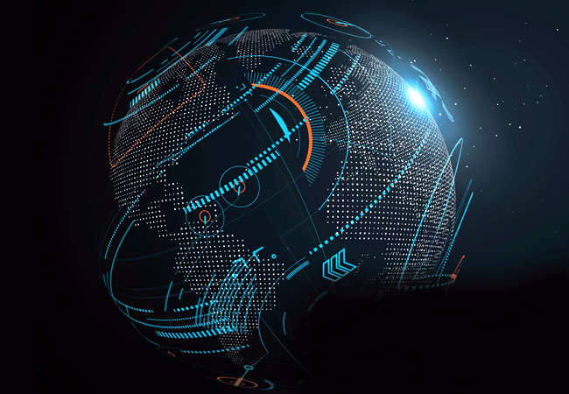

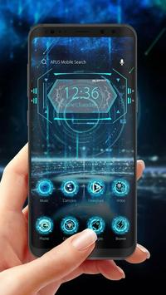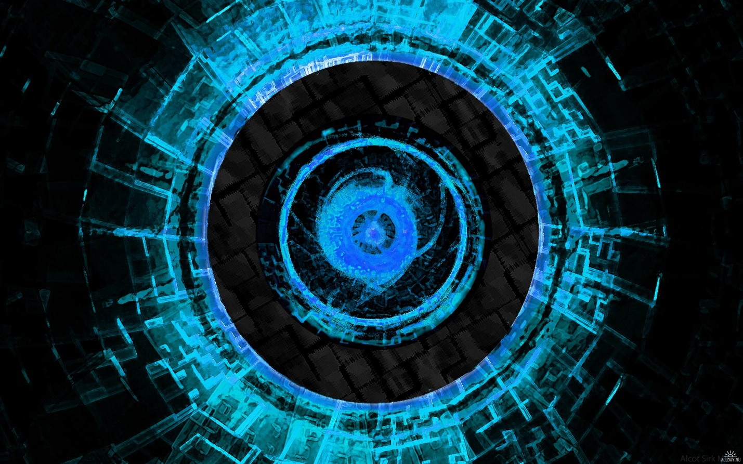

<https://media.istockphoto.com/vectors/helium-vector-minimalist-futuristic-linear-alphabet-typeface-letters-vector-id924073338>



<https://media.istockphoto.com/vectors/3d-polygonal-city-future-futuristic-concept-vector-id883905940>

<https://www.google.nl/search?q=futuristic+head&source=lnms&tbm=isch&sa=X&ved=0ahUKEwi02pe9qOrdAhWEyqQKHVLbA64Q_AUICigB&biw=1670&bih=905>

led met gebroken glas idee:

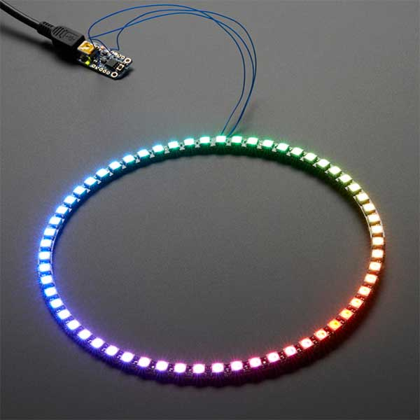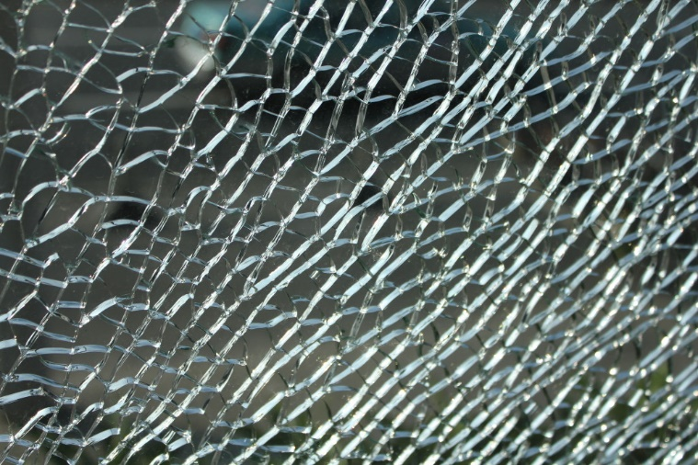

<https://www.hobbyelectronica.nl/product/neopixel-ring-60-x-ws2812-5050-rgb-led/>

<https://www.google.nl/search?q=broken+glas+servies&source=lnms&tbm=isch&sa=X&ved=0ahUKEwj0yM7J0-zdAhUDZlAKHQrmAZkQ_AUICigB&biw=1670&bih=905#imgrc=MmGMhQ_uUGfgbM>: